C229 Single Camera Production – Week 15

Agenda:
- Wrap up semester &review for Final Exam
- Short in-class Canvas attendance exercise
- Fill out the OCQ evaluations this week. If I get 95% participation, I’ll give everyone an extra credit point!

The FINAL EXAM is Wednesday, May 1 from 3-5 pm. (Administered via Canvas. It should literally take no more than 30 minutes. You should have plenty of time to do it- Just Don’t forget to take the final!

Please send me any good Final Projects!

Some last advice:
- Pay attention and be communicative. Never drop the ball. Answer emails quickly and if you don’t know the answer to something, be honest and say you don’t know.
- For people wanting to get into the film/tv business as a creative- start building your portfolio.
- A splash/demo reel is a good thing to have and doesn’t need to be longer than 3 minutes. Always have descriptions of what you did (Director, Sound Design, Editor, etc.) and never include work that you don’t legally own. (It’s good to avoid clip art, stock footage, etc.)
- It’s good to have your own website. You can build it yourself with Wordpress, WIX, SquareSpace, Adobe, etc. or have someone build it for you.
- Ideally, it’s good to have yourname.com.
- It’s also good to not just have pretty pictures and videos on a website- but also articles, Podcasts, etc.
- Many professionals include short articles about the projects they worked on which provide useful context.
- It’s possible to build skills on your own, but much quicker when you work with people who know more than you do.

C229 Review

Review readings & watchlist that were assigned over the semester:
- Lens Basics (Sony)
- Understanding Exposure (B&H Explora)
- Camera Shot Types (B&H Explora)

Review Topics:

Single camera verses multi-camera production (advantages/disadvantages)
Single system vs Dual system production
- Workflow differences (audio, slating, editing, etc.)
Frame Rates/Picture Size: Most TV stations are broadcasting in HD (High Definition), but there are other picture sizes in use. Some include:
- Standard definition (E.g., 720 x 480)
- High definition (E.g., 1920 x 1080)
- 4K and UHD (Ultra High Definition E.g., 3840 x 2160)
Frame Rate: There are two important frame rates to know:
- 24 fps (Actually 23.98 fps)
- 30 fps (Actually 29.97 fps)
Interlaced vs Progressive (60i vs 24p or 30p)
Aperture / f-stop/ iris / Depth of Field
What impacts Depth of Field (Aperture!)
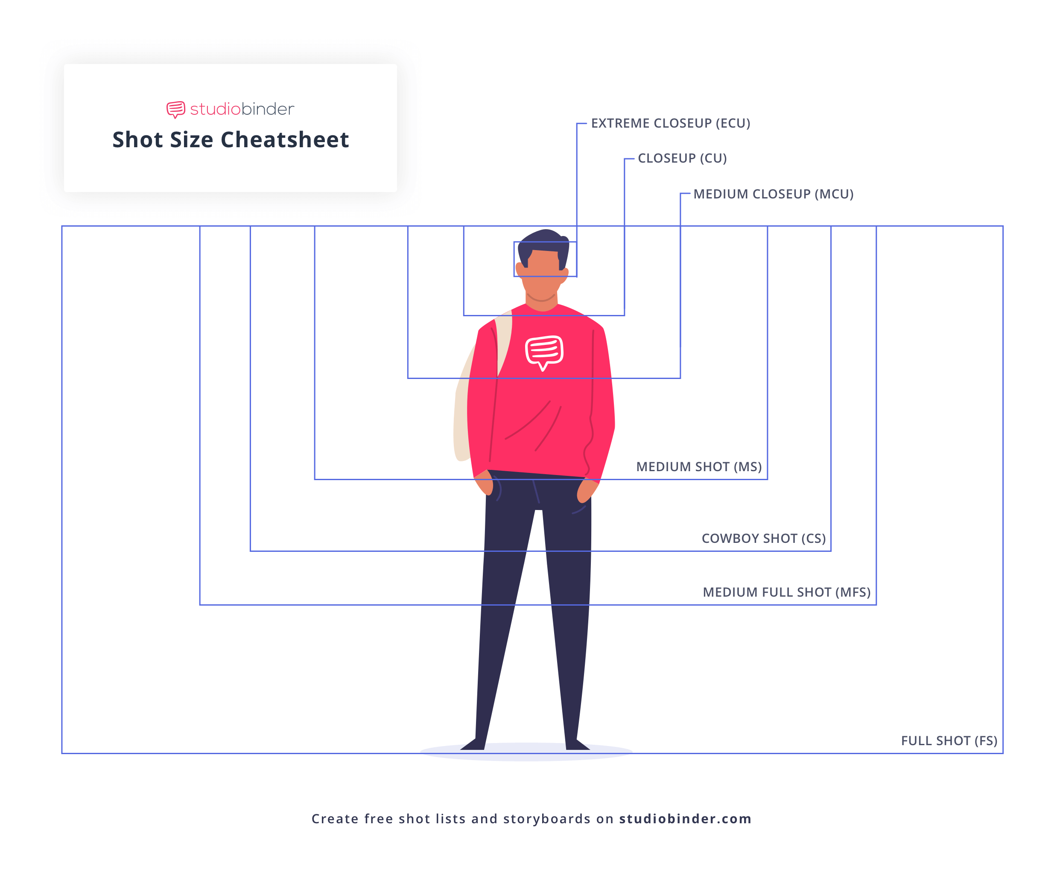
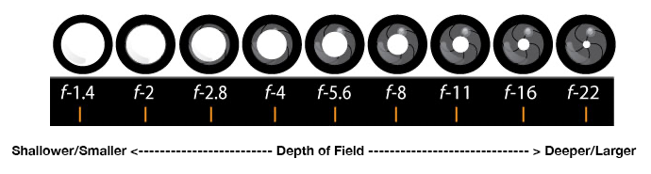
Camera Gain/ISO
Setting Proper Exposure (Tools include Zebra stripes, Waveform Monitor, etc.)
Exposure Triangle (Aperture, ISO/Gain, & Shutter speed)
How to Set Focus (Tools include: Peaking, Magnify, etc.)
How to Set / When to White Balance
Focal length & Angle of View (Telephoto vs Wide Angle)
Prime lenses vs Zoom lens
Shot Types:
Camera settings checklist:
- Initialize SD card before you start filming
- Set your frame rate (either 23.98 for film or 29.97 for TV)
- Set your shutter speed (always double your frame rate 1/48 for film or 1/60 for TV)
- Set your CODEC (mp4, XF-AFC, etc.)
- Set your resolution and bit rate (1920x1080 35mbps or 17mbps)
- White Balance (check/set for proper color temp)
- Check ND filters & Gain/ISO
- Turn on any focus and exposure assists you want to use such as Peaking or Zebra Stripes

Premiere Post Shoot Workflow – After finishing a shoot:
- Copy entire contents of SD/CF card (root/top level) to an appropriately named folder on your dedicated media drive (E.g., “Week 2 Field shoot August 22”).
- Eject the SD/CF card.
- Launch Premiere and save the project to your media drive (E.g., “C229 Project 1”).
  - TIP: It’s good to make sure your Scratch Disks are set to “Same as Project”. You can find this under File/Project Settings.
- Use the Media Browser to link to the footage.
- Import media and edit
  - TIP: Backup your entire media drive to multiple locations (E.g., another SSD).

Lighting
- What is the Lighting Triangle made up of?
- What is the additional, 4th light, we typically add?
- Soft verses Hard lighting
- What are the standard color temperatures for inside and outside?
- Broad verses Narrow lighting
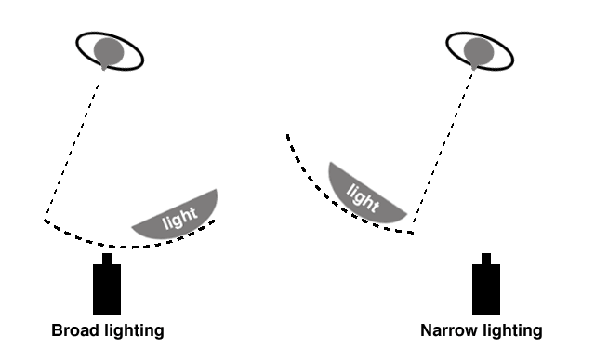

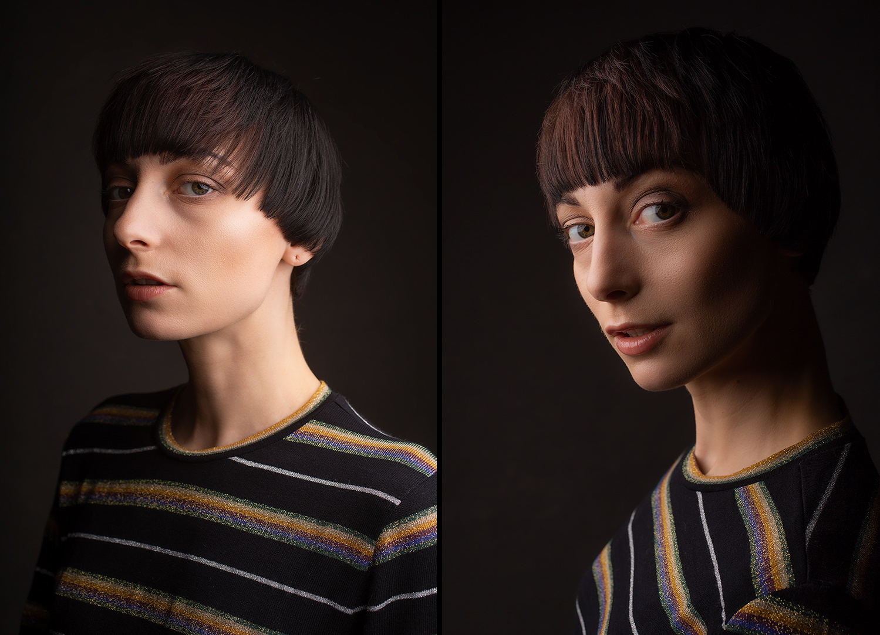

Know different types of lights (Spotlights, softboxes, LED, etc.)

Grips & Gaffers (What’s the difference? Which one works with electricity?)
- How to use C-Stands
- How to carry C-stands
- What to call out when you’re moving gear

Editing – Premiere Basics – NOT going to be on the final!

Directing/Producing
- Continuity Editing in Film (Studio Binder)
  - The 180-degree Rule
  - What’s the 30-degree rule?
  - Match Cuts
  - Eye Trace

Sound
- Range of Human Hearing (20 Hz to 20 kHz)
- Phantom Power
- Types of microphones
- Microphone Polar patterns
- Microphone electrical characteristics (Dynamic, Condenser, etc.)

