**C229 Single Camera Production – Week 15**

**Agenda:**

* Wrap up semester &review for Final Exam
* Short in-class Canvas attendance exercise
* Please fill out the OCQ evaluations this week**. If I get 90% participation, I’ll give everyone an extra credit point!** <https://coursequestionnaire.iu.edu/>

### **Due to popular demand, the C229 FINAL EXAM will be available Monday, May 5 from 9 AM to 9 PM.** It’s open book (feel free to consult the class notes), given via Canvas, and should take about 30 minutes.

### **Just don’t forget to take the final!** (Someone always does….)

Please send me any good Final Projects!

**Some last advice:**

* Pay attention and be communicative. Never drop the ball. Answer emails quickly and if you don’t know the answer to something, be honest and say you don’t know.
* For people wanting to get into the film/tv business as a creative- start building your portfolio.
* A splash/demo reel is a good thing to have and doesn’t need to be longer than 3 minutes. Always have descriptions of what you did (Director, Sound Design, Editor, etc.) and never include work that you don’t legally own. (It’s good to avoid clip art, stock footage, etc.)
* It’s good to have your own website. You can build it yourself with Wordpress, WIX, SquareSpace, Adobe, etc. or have someone build it for you.
* Ideally, it’s good to have yourname.com.
* It’s also good to not just have pretty pictures and videos on a website- but also articles, reflections, etc. It’s important to convey the thinking behind the productions. This is why it’s good to post preproduction work, “making of” articles, and reflections (What have we learned?....).
* Many professionals include short articles about the projects they worked on which provide useful context.
* It’s possible to build skills on your own, but much quicker when you work with people who know more than you do.

**C229 Review - Review readings & watchlist that were assigned over the semester:**

* [Lens Basics (Sony)](https://www.sony.com/ug/electronics/focal-length-angle-of-view-perspective)
* [Understanding Exposure (B&H Explora)](https://www.bhphotovideo.com/explora/photography/tips-and-solutions/understanding-exposure-part-1-exposure-triangle)
* [Camera Shot Types (B&H Explora)](https://www.bhphotovideo.com/explora/video/tips-and-solutions/filmmaking-101-camera-shot-types)

**Review Topics: HINT: Look for 🡨🡨🡨 Know this!**

**Single camera verses multi-camera** production (advantages/disadvantages)

**Single system vs Dual system** production

* Workflow differences (audio, slating, editing, etc.)

**Frame Rates/Picture Size:** Most TV stations are broadcasting in HD (High Definition), but there are other picture sizes in use. Some include:

* Standard definition (E.g., 720 x 480)
* High definition (E.g., 1920 x 1080) **🡨 🡨🡨🡨🡨🡨🡨🡨 Know this!**
* 4K and UHD (Ultra High Definition E.g., 3840 x 2160)

**Frame Rates and Shutter Speeds:** There are two important frame rates to know:

* 24 fps (Actually 23.98 fps). The default shutter speed is 1/48 (twice the frame rate).
* 30 fps (Actually 29.97 fps). The default shutter speed is 1/60 (twice the frame rate).

**Interlaced vs Progressive** (60i vs 24p or 30p)

Aperture / f-stop/ iris / Depth of Field

**What impacts Depth of Field** (Aperture!) **🡨 🡨🡨🡨🡨🡨🡨🡨 Know this!**

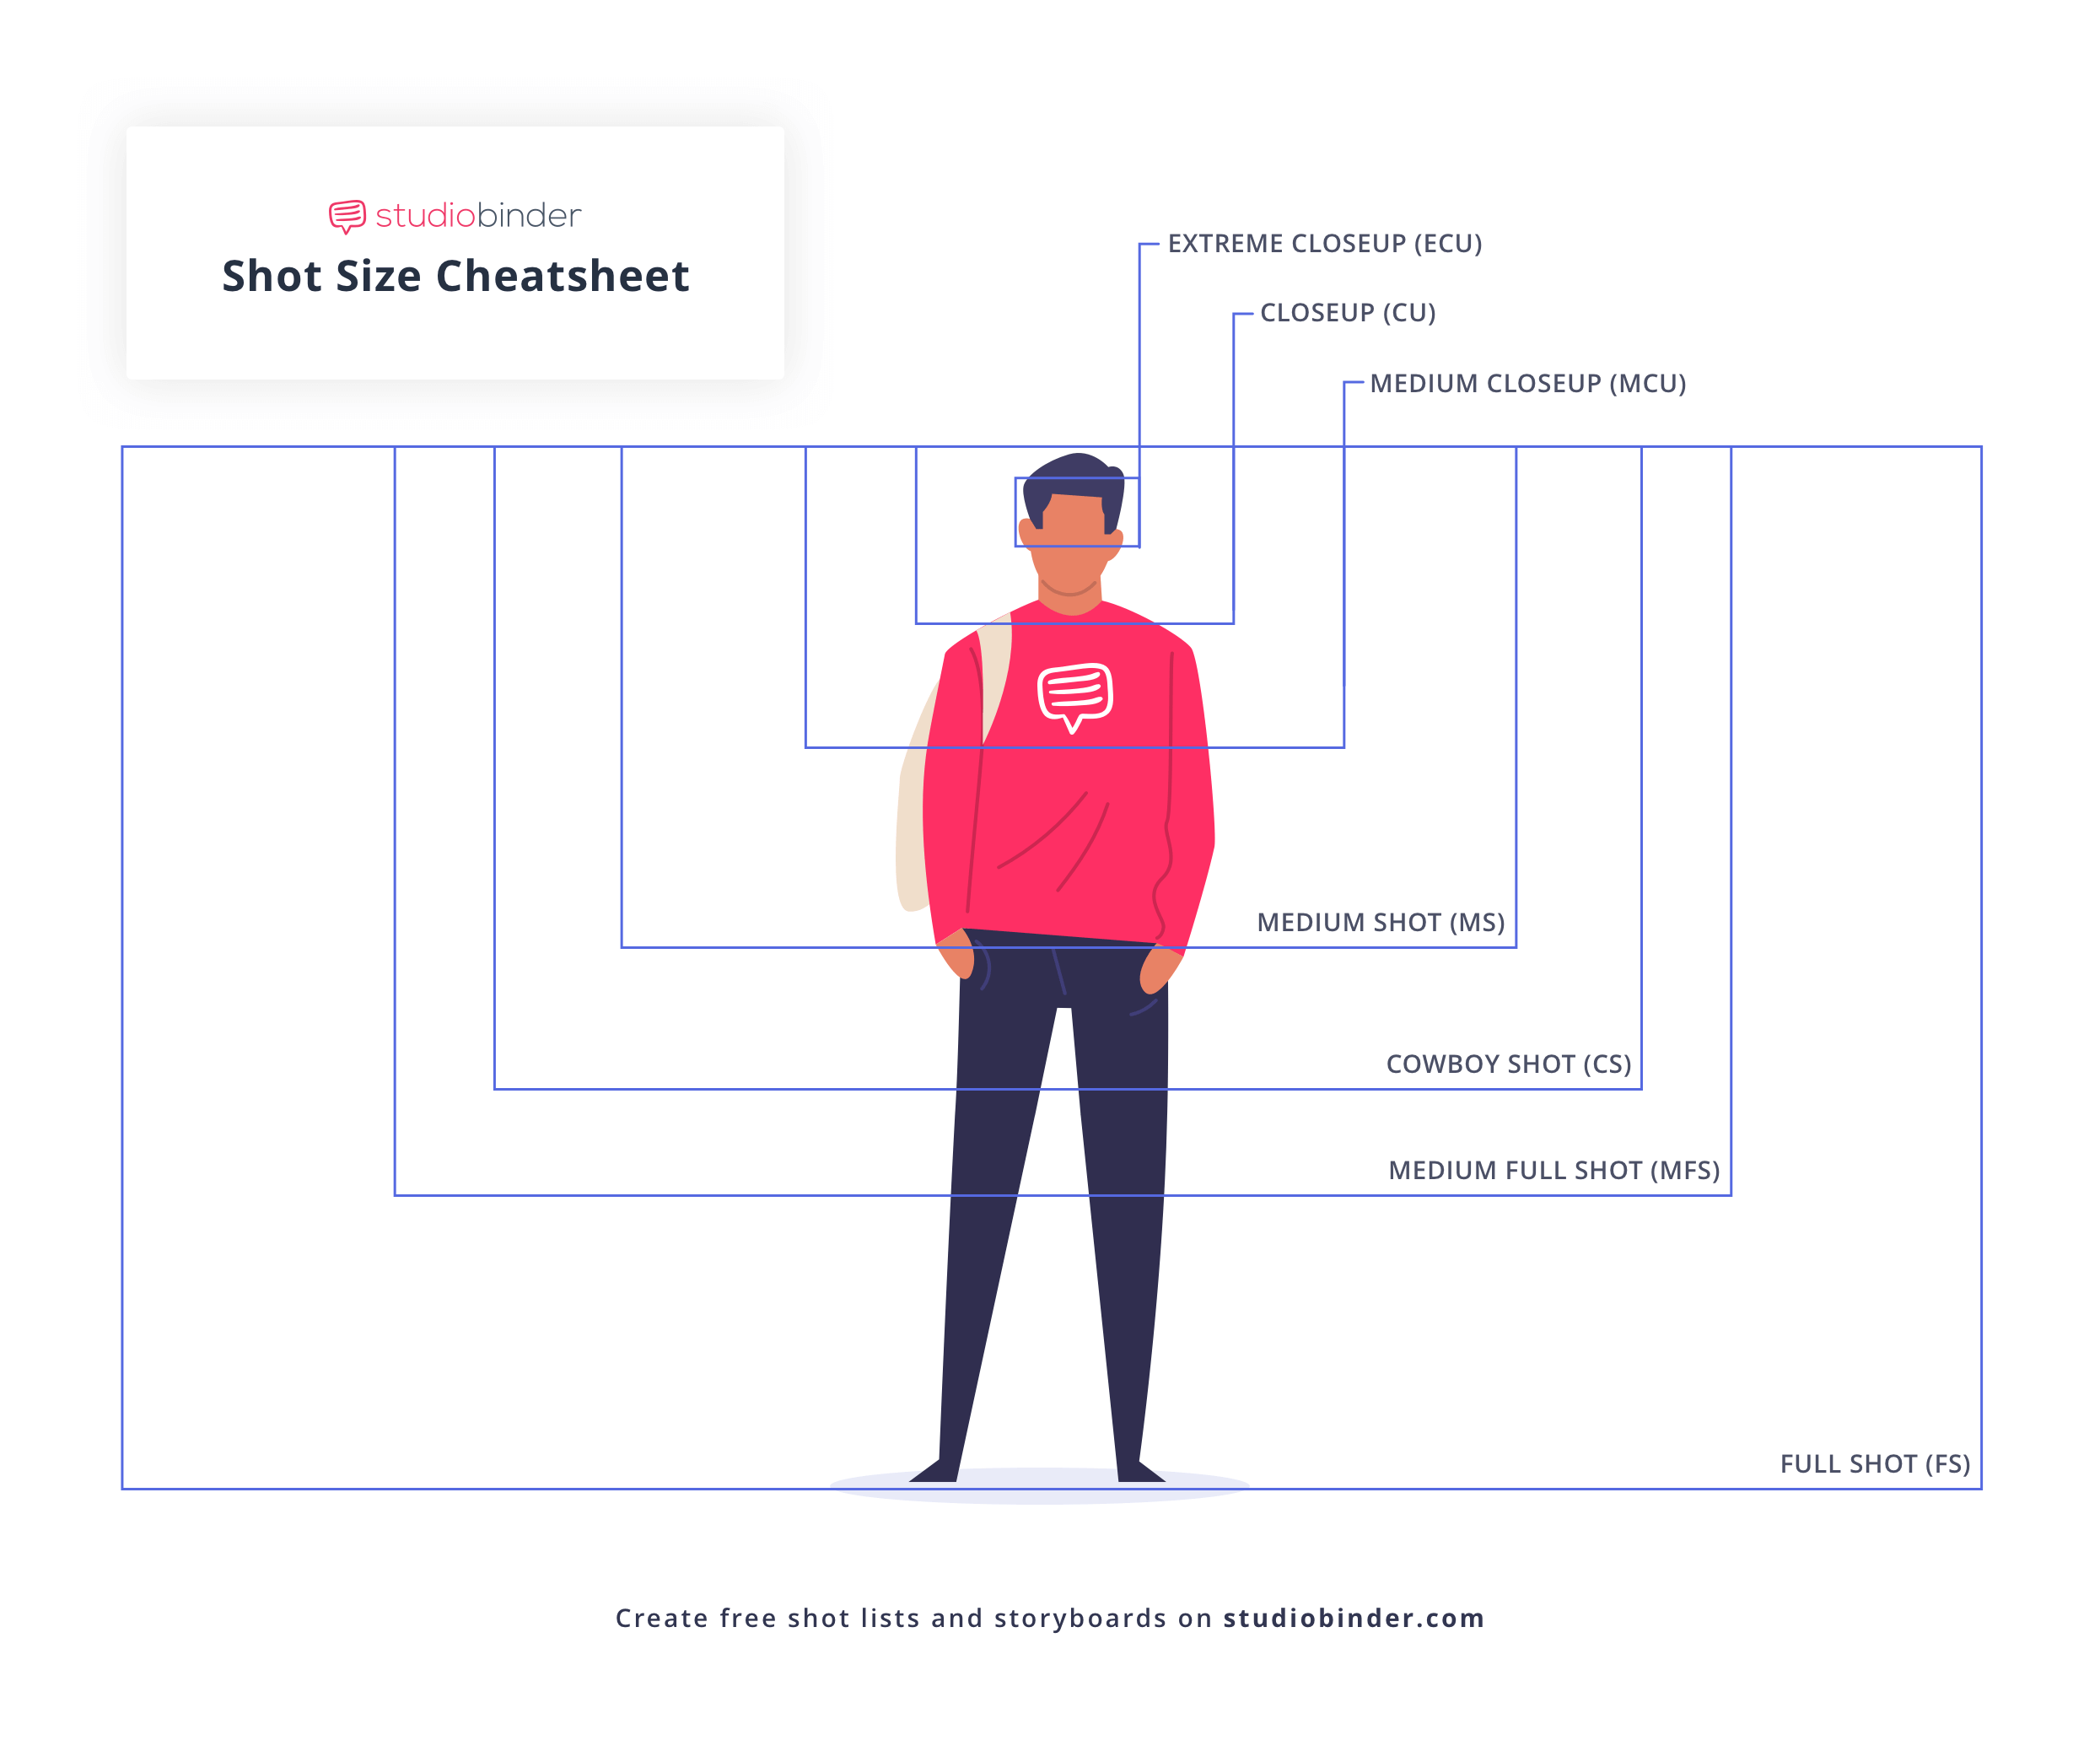

**Camera Gain/ISO**

**Setting Proper Exposure** (Tools include Zebra stripes, Waveform Monitor, etc.)

**Exposure Triangle** (Aperture, ISO/Gain, & Shutter speed)

**How to Set Focus** (Tools include: Peaking, Magnify, etc.)

**How to Set / When to White Balance**

**Focal length & Angle of View** (Telephoto vs Wide Angle)

**Prime lenses vs Zoom lens**

**Shot Types: 🡨 🡨🡨🡨🡨🡨🡨🡨 Know this!**



**Camera settings checklist:**

* Initialize SD card in the camera you’re going to use before filming **🡨 🡨🡨🡨🡨🡨🡨🡨 Know this!**
* Set your frame rate (either 23.98 for film or 29.97 for TV)
* Set your shutter speed (always double your frame rate 1/48 for film or 1/60 for TV)
* Set your CODEC (mp4, XF-AFC, etc.)
* Set your resolution and bit rate (1920x1080 35mbps or 17mbps)
* White Balance (check/set for proper color temp)
* Check ND filters & Gain/ISO
* Turn on any focus and exposure assists you want to use such as Peaking or Zebra Stripes

**Premiere Post Shoot Workflow** – After finishing a shoot:

* Copy entire contents of SD/CF card (root/top level) to an appropriately named folder on your dedicated media drive (E.g., “Week 2 Field shoot August 22”).
* Eject the SD/CF card.
* Launch Premiere and save the project to your media drive (E.g., “C229 Project 1”).
  + TIP: It’s good to make sure your Scratch Disks are set to “Same as Project”. You can find this under File/Project Settings.
* Use the Media Browser to link to the footage.
* Import media and edit
  + TIP: Backup your entire media drive to multiple locations (E.g., another SSD).

**Lighting**

* What is the average color temperature for outdoor light? For indoor tungsten light? **🡨 Know this!**
* What is the Lighting Triangle made up of? **🡨 🡨🡨🡨🡨🡨🡨🡨 Know this!**
* What is the additional, 4th light, we typically add?
* Soft verses Hard lighting
* What are the standard color temperatures for inside and outside?
* Broad verses Narrow lighting

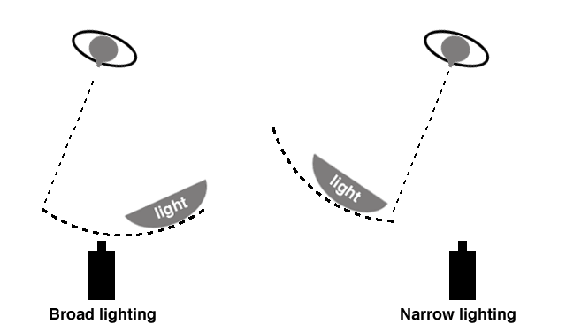

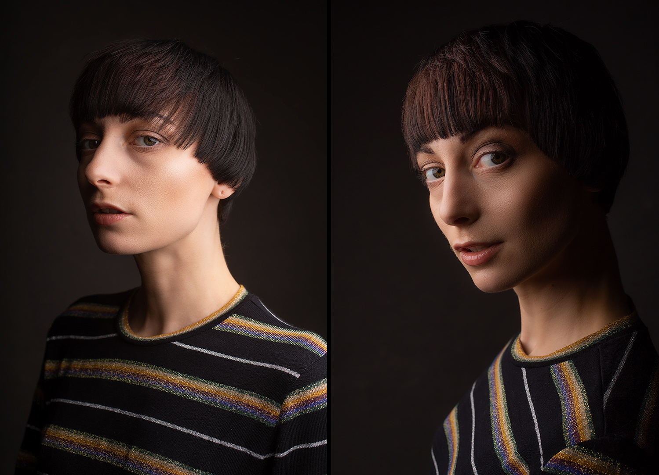

Know different types of lights (Spotlights, softboxes, LED, etc.)

**Grips & Gaffers** (What’s the difference? Which one works with electricity?)

* How to use C-Stands
* What leg of the C-stand does the sandbag go on? **🡨🡨🡨🡨🡨🡨🡨🡨 Know this!**
* How to carry C-stands
* **What to call out when you’re moving gear 🡨 🡨🡨🡨🡨🡨🡨🡨 Know this!**

Editing – Premiere Basics – NOT going to be on the final!

**Directing/Producing**

* [Continuity Editing in Film (Studio Binder)](https://www.studiobinder.com/blog/what-is-continuity-editing-in-film/)
  + [**The 180-degree Rule**](https://youtu.be/iW0bKUfvH2c) **🡨 🡨🡨🡨🡨🡨🡨🡨 Know this!**
  + [What’s the 30-degree rule?](https://youtu.be/1K8EUc98VoQ)
  + [Match Cuts](https://youtu.be/ptXlYulVAsM)
  + [Eye Trace](https://youtu.be/xUK64UkTmW0)

**Sound**

* Range of Human Hearing (20 Hz to 20 kHz)
* Phantom Power
* Types of microphones & Polar pickup patterns
* Microphone electrical characteristics (Dynamic, Condenser, etc.)

**Final Week 15 engagement/participation question(s):**

Please list one thing that was working well (E.g., Don’t change this!) and one thing that could be better/improved.

Thanks for the great semester! ☺