C229 Single Camera Production

Week 2-3 Topics:
- Readings
- Camera framing, exposure, and focus
- Workflow
- Camera settings checklist
- Intro to Canon xf605

Readings:
- Lecture notes distributed via Canvas announcements
- Canon xf605 manual: https://jk.media.indiana.edu/resources/xf605_manual.pdf
- (Don’t read it cover to cover, just familiarize yourself with it, get to know the menu structure, and see how to control the various camera settings. Consider downloading it to your phone.)
- Lens Basics (Sony): https://www.sony.com/ug/electronics/focal-length-angle-of-view-perspective
- Understanding Exposure (B&H Explora): https://www.bhphotovideo.com/explora/photography/tips-and-solutions/understanding-exposure-part-1-exposure-triangle
- Camera Shot Types (B&H Explora): https://www.bhphotovideo.com/explora/video/tips-and-solutions/filmmaking-101-camera-shot-types

Framing - It’s good to know basic shot types. Some apply to subjects (2-shot, Over the Shoulder, etc.) and others apply to landscapes or other subjects. See the B&H Explora article on shot types and the Cheat Sheet below from Studio Binder.

Some lenses are made for getting specific types of shots. A telephoto lens can be used to photograph a faraway subject. These have a very narrow angle of view.

A wide-angle lens can be used to capture a large field of view. These can have a very wide angle of view (E.g., 180° on a fisheye lens)

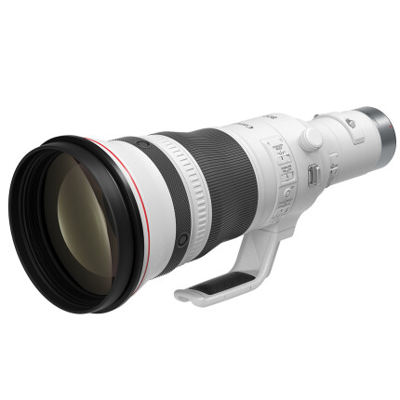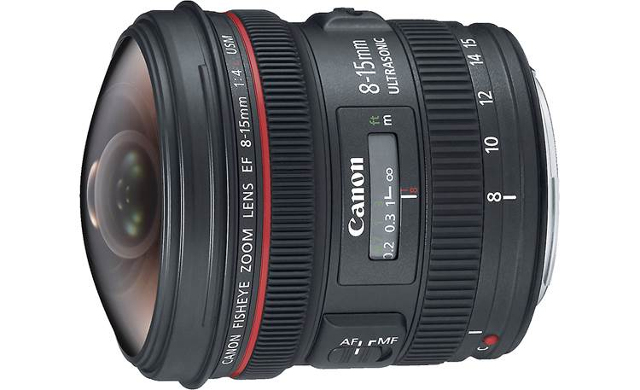

Telephoto Wide-angle lens

For framing people, this reference from Studio Binder is a good cheat sheet.
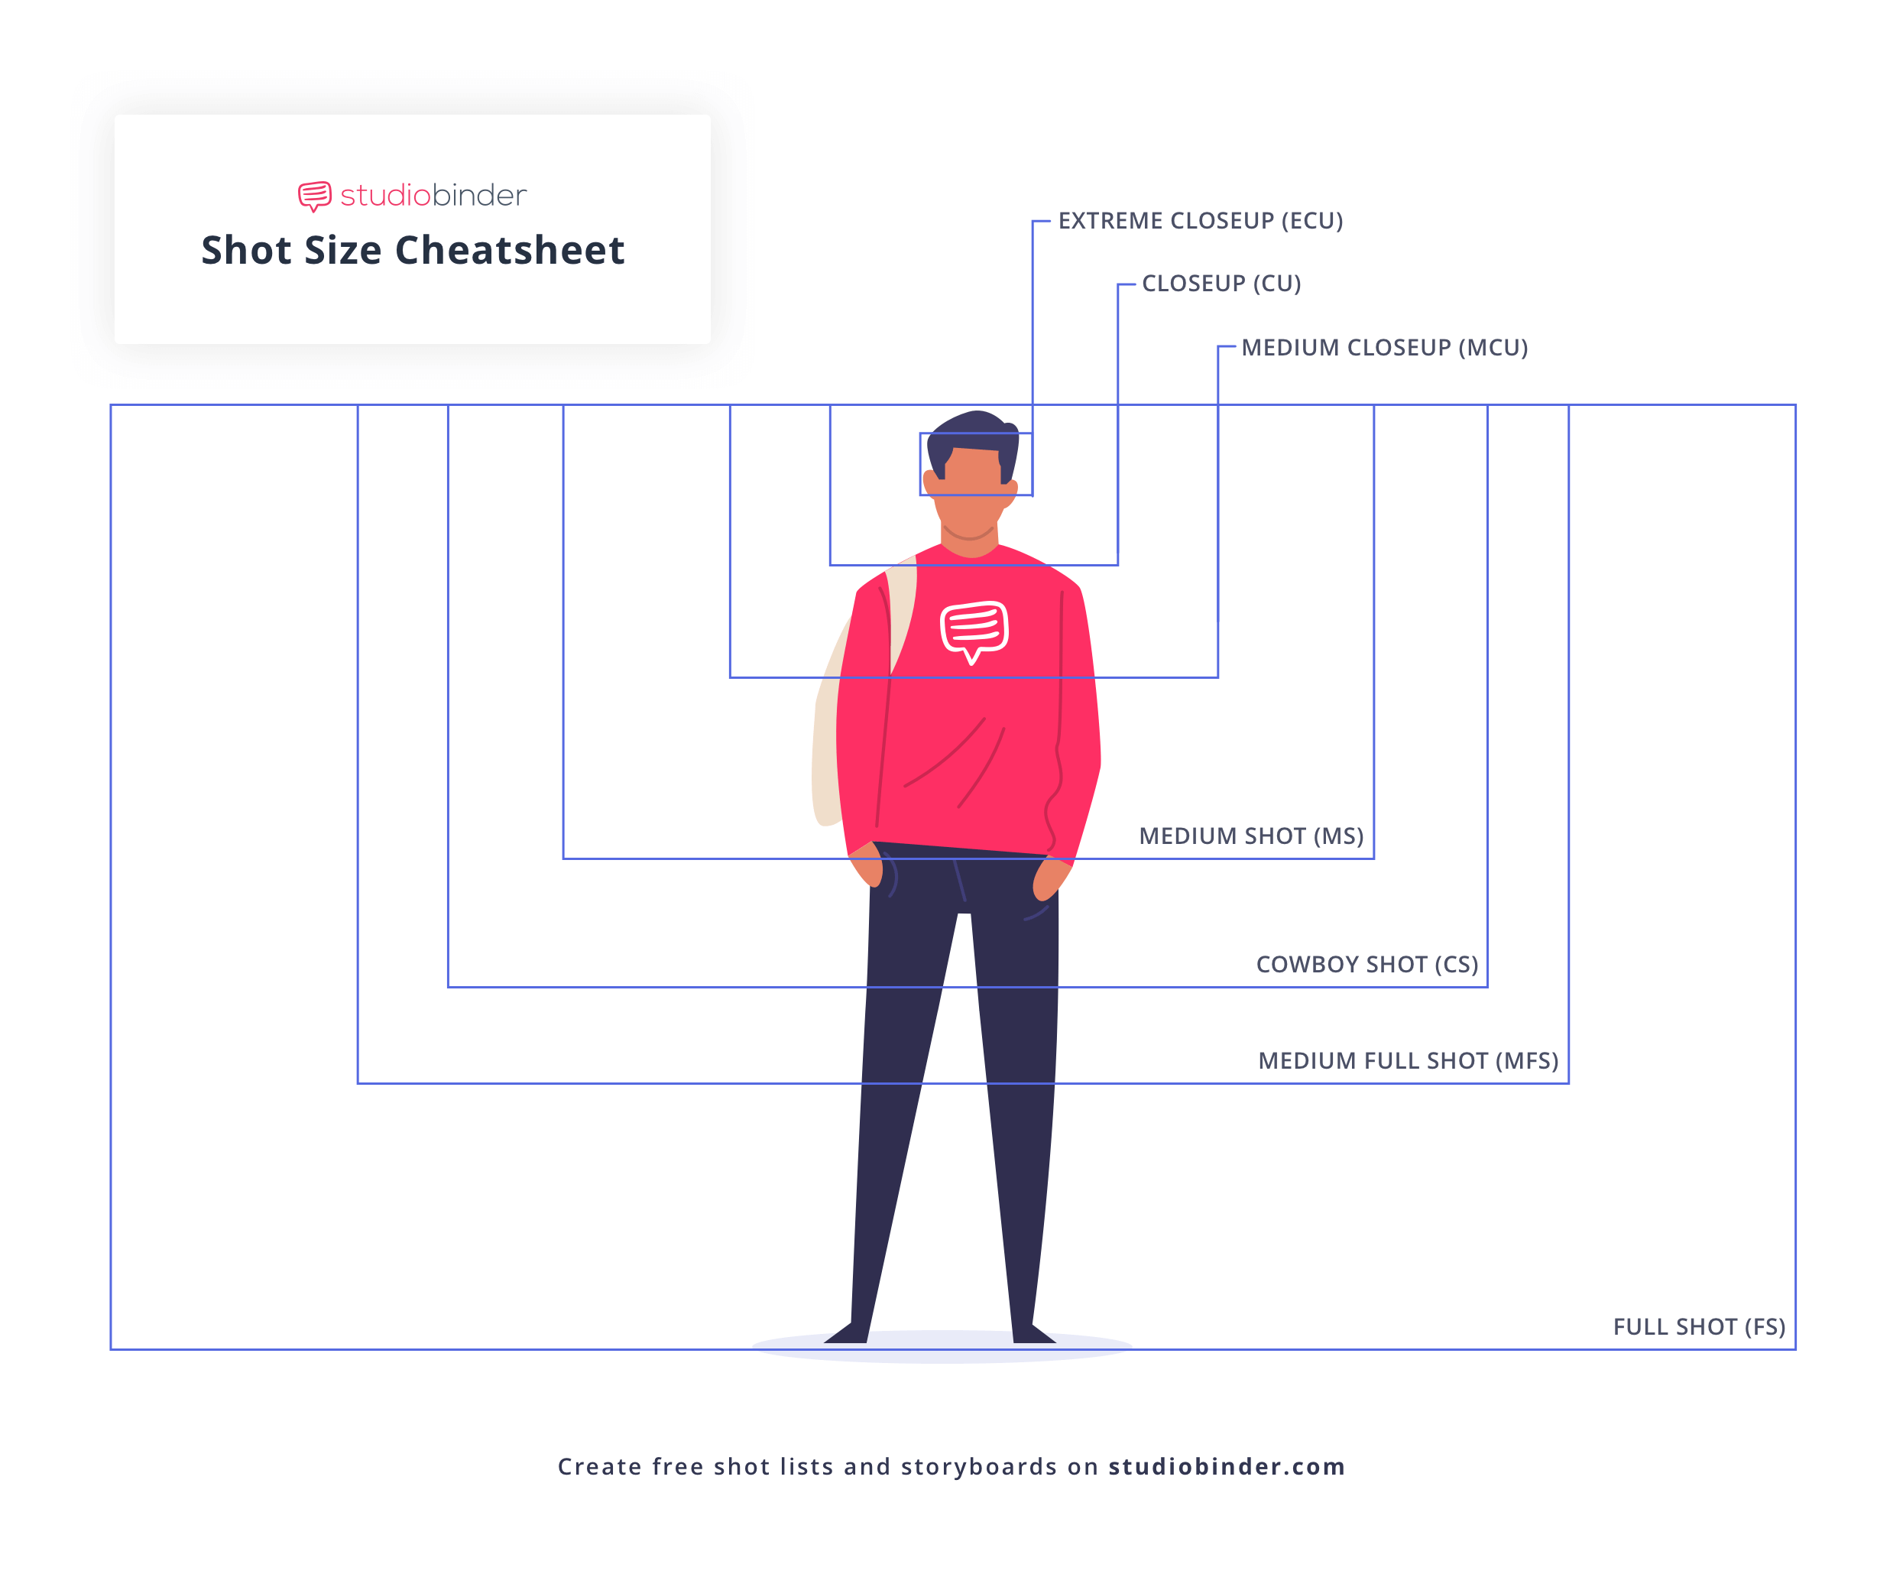
Aperture and Depth of Field

Depth of field refers to the range of what’s in focus. Sometimes we want a shallow depth of field (E.g., for portraiture) and other times we want a large one (E.g., for landscapes).

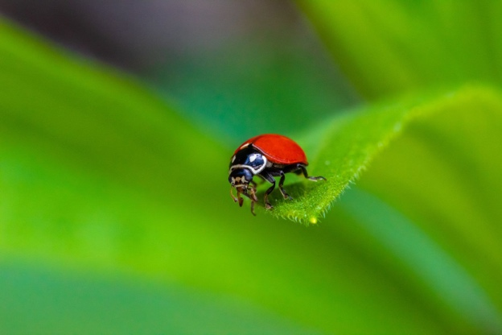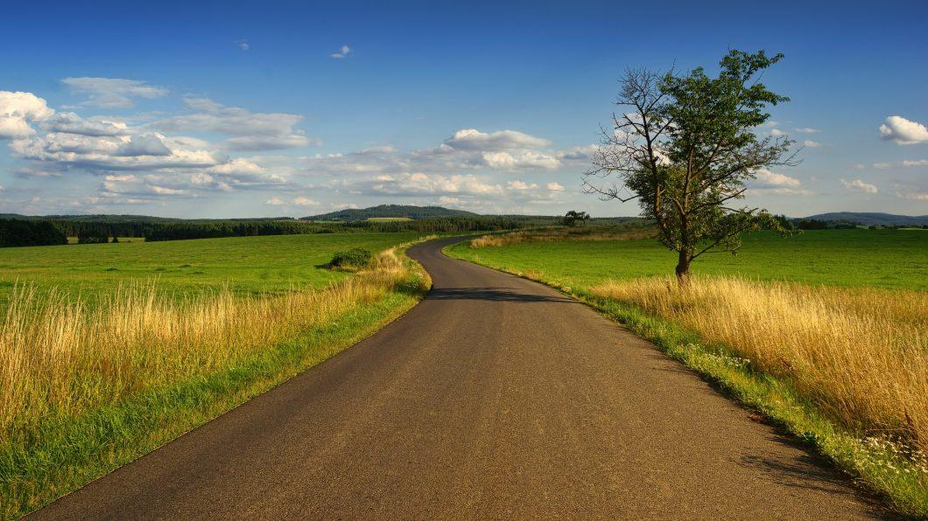
Shallow depth of field Large depth of field

Aperture affects depth of field. Larger apertures, like f-2 will have a shallower depth of field and smaller apertures, like f-22 will have a deeper or larger depth of field.

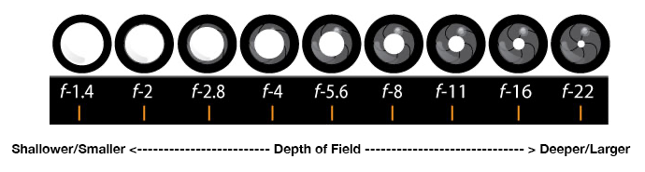
Camera Gain/ISO, Exposure, Focus, & White Balance – While these can all be set to “auto” it’s important to know how to set these manually.

Gain/ISO - For those who’ve shot with DSLRs, you might be familiar with ISO. In video cameras we usually use the term Gain. Gain and ISO are similar, referring to the same idea- the sensitivity to light. Gain is expressed in dBs while ISO is expressed in a numerical value.

Increasing the gain or ISO electronically boosts or amplifies the signal. This increases the image’s luminance (brightness) but also adds noise. (For audio, boosting the gain does the same thing- increasing the gain but at the cost of adding noise.)

Ideally, we want to shoot with as low a gain/ISO setting as possible. This gives us the cleanest, most noise-free signal.

Sometimes we must shoot in a dark location (nightclub, cave, at night, etc.). While we’d ideally add light to the scene, this is often not possible. In these cases, we can increase the camera’s ISO/Gain, electronically boosting the luminance of the video.

Exposure can be objectively measured and represented with a waveform monitor, which displays the luminance value (brightness) of an image in IRE values. (The Canon xf605s have this feature!) If we were to examine SMPTE color bars (a standard reference signal), they would appear as such:

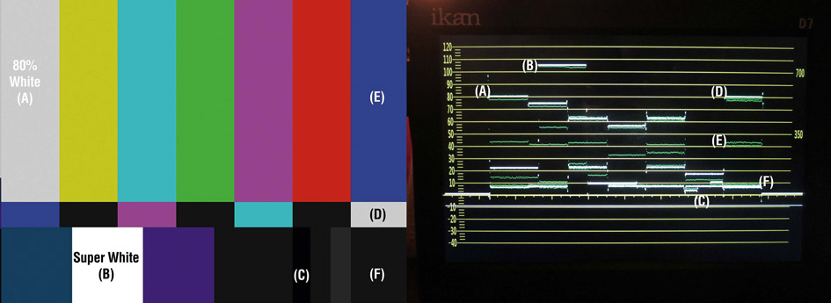

The maximum (legal) luminance (brightness) value is 100 IRE. The lowest (darkest) part is 0 IRE.
We want our image to fall inside of the accepted exposure range- between 0 and 100 IRE.

Exposure Triangle - You might’ve heard of the exposure triangle. https://www.bhphotovideo.com/explora/photography/tips-and-solutions/understanding-exposure-part-1-exposure-triangle

Developed for film cameras, it essentially states that you have 3 parameters you can control: aperture, ISO (Gain), and shutter speed. We can apply it to video cameras, but when shooting film or video, we are locked into our shutter speeds.

Exposure Assist Tools – There are tools found on most video cameras that help with getting proper exposure:
- Zebra stripes
- Waveform monitor

Instead of making subjective decisions based on the LCD monitor or viewfinder, use the Zebra Stripes or Waveform Monitor features.

Zebra stripes can be set to appear when you reach a preset IRE level. (These appear on the viewfinder or monitor and are not recorded.)

Common levels to set zebra stripes are 70 IRE (for Caucasian skin tones under typical lighting conditions), 95 and 100 IRE to show when you’re close to or have reached the maximum exposure level.

Perfect Camera Exposure (YouTube): https://youtu.be/95q92gWeYUM

Waveform Monitor – Some cameras, (like the Canon xf605) provide a waveform monitor display that can be superimposed onto the viewfinder. This is an excellent way to objectively assess your luminance levels. (Canon UK 605 tech page)

How to achieve proper exposure with a video camera - Start with the lowest gain/ISO setting. If the image is too dark, open the aperture (iris). If you can’t add light, then boost the gain/ISO.

Neutral Density (ND) filters - If there is too much light to use the desired f-stop, then add ND filters until you can achieve the proper exposure.

Focus Assist Tools – There are several focus-assist tools on the Canon xf605. These features can be found on other cameras as well. They can be switched on/off via buttons on the camera, or through the menu:
- Peaking is a feature that draws colorful outlines around the areas that are in focus. (These aren’t recorded, just displayed on the viewfinder/monitor.) It’s useful to set them for a color that’s easy to see, like red. (example)
- Magnify is a feature that expands/enlarges the image- so we can get a closer look at critical elements within the frame. Like Zebra Stripes and Peaking, Magnify is a feature that appears on the viewfinder/monitor- it’s not recorded. (Look for the button near the record switch.)
- Focus Guide - The Canon xf605 has a useful Focus guide assistant. When in manual focus mode (and turned on), it’ll indicate when something is in focus. You can touch the screen to move it around. You must turn this on through the menu (example).

White Balance – You can use a preset color temperature setting (E.g., 3200K for indoor and 5600K for outdoor) or manually white balance to suit your location. It’s good to manually white balance when in non-standard lighting environments (under mercury vapor lights, in shadows, etc.).

Set/check your white balance whenever you change lighting conditions.

Camera settings checklist:
- Initialize SD card before you start filming
- Set your frame rate (either 23.98 for film or 29.97 for TV)
- Set your shutter speed (always double your frame rate 1/48 for film or 1/60 for TV)
- Set your CODEC (mp4)
  - NOTE: You can choose the XF-AVC codec, but you end up with a much larger file, which makes it more difficult to edit.
- Set your resolution and bit rate (1920x1080 35mbps or 17mbps)
- White Balance (check/set for proper color temp)
- Check ND filters & Gain/ISO
- Turn on any assists you want to use such as Peaking or Zebra Stripes

FYI When formatting cards, the Canon xf605 behaves differently with different types of media. SD cards are initialized using the FAT file system, SDHC cards using the FAT32 file system, and SDXC cards using the exFAT file system.

Premiere Post Shoot Workflow – After finishing a shoot:
- Copy entire contents of SD/CF card (root/top level) to an appropriately named folder on your dedicated media drive (E.g., “Week 2 Field shoot August 22”).
- Eject the SD/CF card.
- Launch Premiere and save the project to your media drive (E.g., “C229 Project 1”).
  - TIP: It’s good to make sure your Scratch Disks are set to “Same as Project”. You can find this under File/Project Settings.
- Use the Media Browser to link to the footage.
- Import media and edit
  - TIP: Backup your entire media drive to multiple locations (E.g., another SSD).

Vocabulary:
- Angle of view (Telephoto lenses have narrow angles of view, while wide angle lenses have wide, or large angles of view.)
- Aperture (Iris) - The opening that light passes through described in f-stops.
- Depth of field - the range of distance that objects will be in focus
- Exposure Triangle – includes aperture, shutter speed, and ISO
- F-stop - These numbers are inversely related to size of the aperture or iris opening. Small f-stops (E.g., f2) represent a larger aperture and large f-stops (E.g., f-22) represent a smaller aperture
- Focal length
- Gain/ISO
- ND filters - Neutral density filters don't influence the color temperature. They are gray and translucent. Their purpose is to reduce the amount of light coming into the camera.
- Peaking – a focus assist feature
- Prime lens - A lens with a fixed focal length.
- Zebra Stripes – a camera feature that displays when a preset exposure/IRE level has been reached
- Zoom lens - A lens that has a variable focal length

2 Questions (just give the answers):
- Which f-stop should I use to capture an Ansel Adams-like deep focus landscape image? (Everything near and far should be in sharp focus.)
- Which f-stop should I use to get a cinematic portrait of my subject with the shallowest depth of field?

