C229 Lecture Week 5 – What Grips Do - Lighting 202

Agenda:
- Lighting (continued)
- Grip Department

Reading/Watchlist:

Here are 2 good webpages of film terms:
- https://www.bhphotovideo.com/explora/video/tips-and-solutions/guide-film-set-lingo-and-hand-signals
- https://www.studiobinder.com/blog/movie-film-terms/
This is a great resource page with excellent embedded videos:
- https://www.studiobinder.com/blog/how-to-use-c-stand/
- On shaping light with flags and nets: https://youtu.be/ShFk1Ao9sBw
- Grip Tips: The C-Stand https://youtu.be/3LXexXE0Dxo
Lastly, be sure to watch Grip it Good, a great overview on what grips do:
- https://vimeo.com/82248530

Lighting (Continued)

Last week we looked at two types of lighting instruments: spotlights, which produce focused beams of light (hard light) and create sharply defined shadows and floodlights, which create softer, more diffused light.

Common types of spotlights:

Fresnel: These are named for the lenses. Fresnel lenses are made with a concentric series of rings milled into them, which help focus the light. Fresnel spotlights are versatile, as their beams can be focused from narrow (spot) to wide (flood).
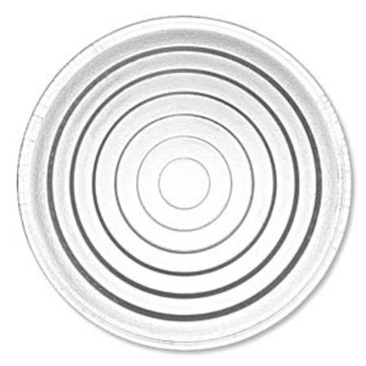 | 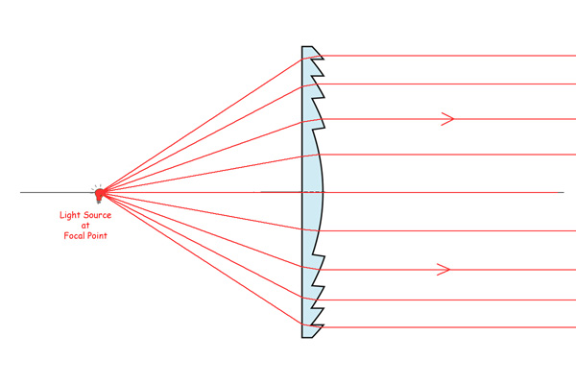

Fresnel spotlights (like the Arri 300 pictured below) should be used with barndoors, which help direct light and reduce unwanted spill.

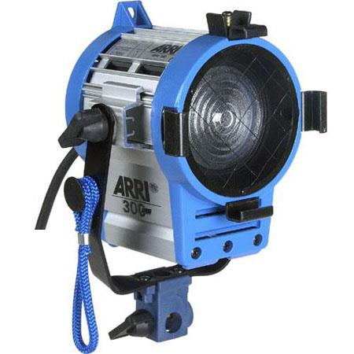 | 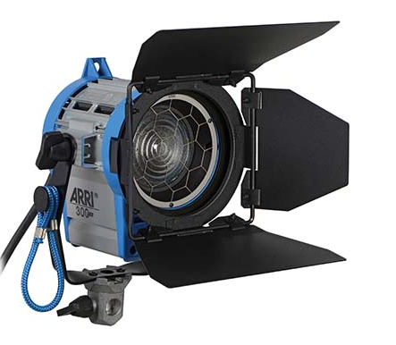
Arri 300 watt Fresnel | Arri 300 with barndoors

Barndoor holders can also be used to mount scrims, filter frames, and speed rings to mount soft boxes.
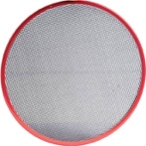 | 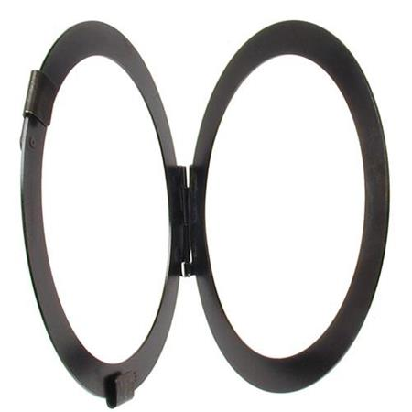 | 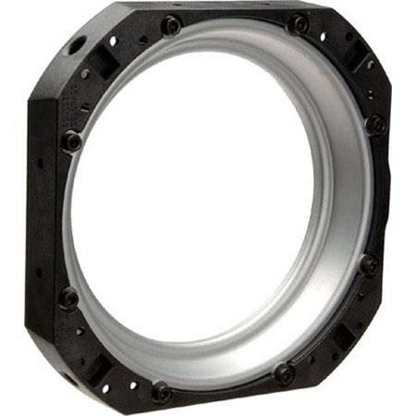
Scrim | Filter/Gel Frame | Speed Ring

Open-Faced Spotlights like the Arrilite 750 Plus (pictured below) emit harsh light because they don’t have a lens- just a protective wire mesh. They are basically a light in front of a reflector. As a result, they aren’t ideal to serve as a subject’s key light. However, they are ideal for using with a softbox. This makes them perfect for creating soft key light.

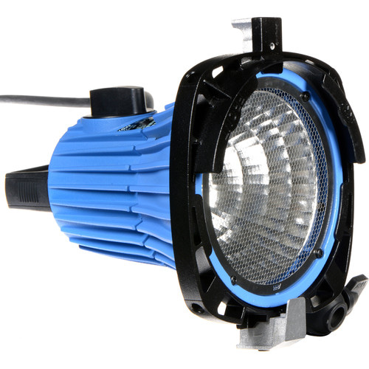 | 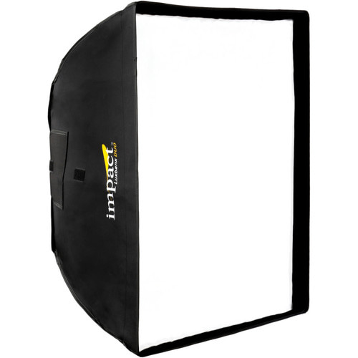
Arrilite 750 Plus with speed ring | Impact Softbox

Softboxes turn hard light coming from a spotlight into soft light.

There are other types of spotlights (ellipsoidal, par cans, HMI, etc.) but Fresnel and open-faced lights are commonly found on set and in the Media School inventory.

LED Lighting

LED lighting comes in a wide range of shapes and sizes. Small LED lights can be considered spotlights, since their smaller surface area creates harder, more focused light. Larger LED panels and ring lights create softer light, like a floodlight. Many have variable color temperatures (3200K-5600K) so they can be used inside or outside. B&H LED Lights

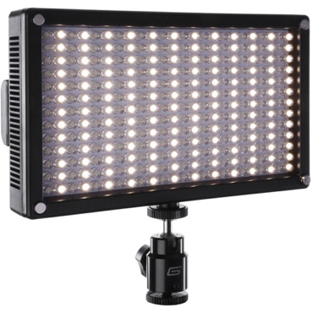 | 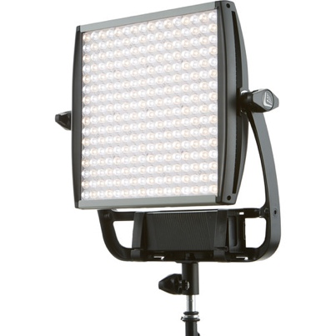 | 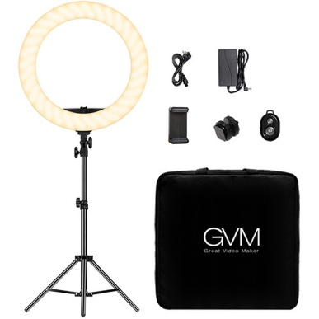 | 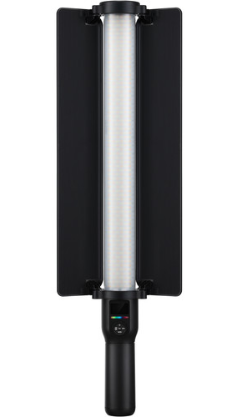
Genaray 7100T | Lightpanels Astra | GVM Ringlight | GVM Light Stick

LED lights use less electricity than tungsten lights and generate less heat as well. Because of this, they can often be powered with batteries. Because of their small size and battery power, they can be positioned in tight areas and interesting locations.

Grip Department

Grips & Gaffers (What’s the difference?)

- Gaffers work with lighting and electricity. Best Boy/Girl is the Assistant to the Chief Electrician
- Grips (led by the Key Grip) rig and control lights and cameras- but don’t do electrical work.

Heat & Power Consumption - Unlike flash and strobe lighting used for still photography, film/video production requires "constant on" devices, which can use significant amounts of electricity and generate a lot of heat. LED fixtures are usually not an issue, but tungsten lights can use lots of electricity and pose a potential fire hazard. Parameters of electricity include:
- Voltage (volts) Referred to as the letter E in some formulas.
- Amperage (amps aka current) Referred to as the letter I in some formulas.
- Resistance (ohms) Referred to as the letter R in some formulas.
- Watts (a.k.a. Power) Referred to as the letter P in some formulas.

US household electrical circuits are usually 120 volts at either 15 or 20 amps. (240-volt circuits are also used, but for larger equipment and lighting.) If too much current passes through a circuit, a circuit breaker should trip, cutting off power.

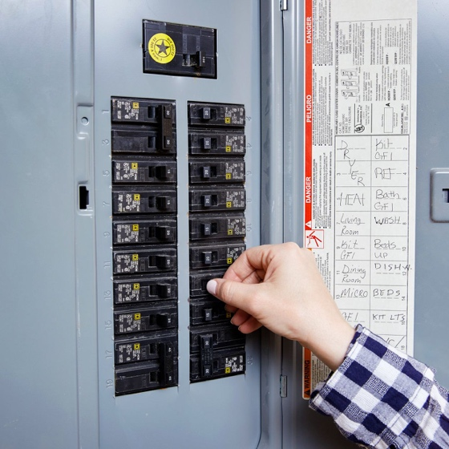 | 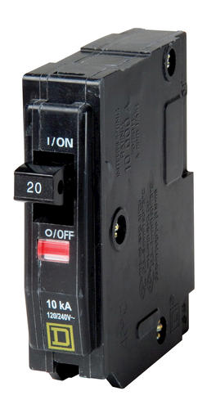
Circuit Breaker Box | 20 Amp Circuit Breaker

Formulas used to calculate electrical/lighting loads:
- Ohm’s Law is I = E/R This formula states the relationship between voltage (E), current (I), and resistance (R). Variations of this are R=E/I, and E=IxR.
- Watts = Amps x Volts Variations of this are W/Amps = Volts, or W/Volts=Amps

When lighting on set or in the field, keep track of electrical loads, especially when using high-wattage tungsten devices. Think about if you were using three 650-watt Arri Fresnel spotlights. The three lights would need a total of 1950 watts (650 x 3 = 1950). Given a common 120-volt circuit: 1950 watts/120 volts = 16.25 amps. This would trip the breaker of a 15-amp circuit.

Maximum Wattage for Common Circuit Breakers: 15 amp = 1,800 watts 20 amp = 2,400 watts
Winding Cables

Master the “over/under” method of winding cable. It applies to ropes, mic cables, electrical cables, and long camera/video/BNC cords. You can practice in lab this week.

“How to” video examples:

- https://youtu.be/cpuutP6Df84
- https://youtu.be/KHwPthJO5bo

C-Stands

C-stands are essential tools on film sets. You can attach lighting devices to them, accessories such as flags and nets, and monitors and more.

Watch the videos from the watchlist, which cover the important aspects of setting up, carrying, and stacking C-Stands.

Some important things to remember:

- Align the gobo arm (carrying the weight) over the tallest leg.
- Sandbags go on the tallest leg and should not touch the ground.
- When picking up C-stands, grasp both the gobo arm and the stand.
- When carrying large pieces of gear call out “Points” especially when around people or turning blind corners.
- When mounting gear to grip heads remember: Righty-tighty/Lefty-loosey This ensures that the weight of whatever’s attached will help tighten the arm and not loosen it.

Attendance Question (There’s just one today):

What kind of spotlight uses the lens below?

