**C229 Single Camera Production – Week 7**

Week 7 Agenda:

* Readings/watchlist
* Review camera framing, angle of view & f-stop
* Image Sensors, lenses, and mounts
* Intro to the Canon C100 & R5C
* Review 1st Visual Narrative Project & Visual Narrative example

**Announcements**: Please send me any good Campus Symphony projects!

**Readings/Watchlist:**

* [Canon C100 Mark II manual](https://jk.media.indiana.edu/resources/Canon_eosc100-mk2.pdf) + [MSCH C100 Training video](https://sites.mediaschool.indiana.edu/learn/895-2/)
* [Canon R5C manuals](https://www.usa.canon.com/support/p/eos-r5-c?srsltid=AfmBOopmfshMHEY2lQwbCgYMZ9sSbNiETOXwqSVTqa70npRAtkT1ulqX)
* [Canon R5C Camera Controls and Menus – Part I](https://www.youtube.com/watch?v=ExsnfHh-OzY)
* [Canon R5C Camera Controls and Menus – Part II](https://www.youtube.com/watch?v=xFZsTWgLFS0)
* Review: [Lens Basics (Sony)](https://www.sony.com/ug/electronics/focal-length-angle-of-view-perspective) & [Camera Shot Types (B&H Explora)](https://www.bhphotovideo.com/explora/video/tips-and-solutions/filmmaking-101-camera-shot-types)
* [Cuts & Transitions 101 (Rocket Jump Film School)](https://www.youtube.com/watch?v=OAH0MoAv2CI)

**Framing –** Be sure you know your basic shot types. Review the [B&H Explora article on shot types](https://www.bhphotovideo.com/explora/video/tips-and-solutions/filmmaking-101-camera-shot-types) and the Cheat Sheet below from Studio Binder.



|  |  |
| --- | --- |
| The Rule Of Thirds | What is it? Filmmaking & Photography Training - YouTube | Rule of thirds in Movies - Media Maker Academy | Rule of thirds, Framing  photography, Composition photography |
| When framing medium close-ups, close-ups, and extreme close-ups, it’s common practice to keep eyes positioned on the top line of the rule of thirds. See how the eyes are positioned on the top line and that lead room is given in both images? Lead room is extra space in the frame provided in the direction of a gaze or movement. | |

When framing and setting up shots, keep in mind the camera lens’s focal length and angle of view. A telephoto lens has a narrow angle of view (E.g., 10°) while a *wide-angle* lens has (as it’s named), a wider angle of view (E.g., 180° on a fisheye lens). It’s possible to get a close-up with either lens below- but the angle of view and placement of the camera would be drastically different.

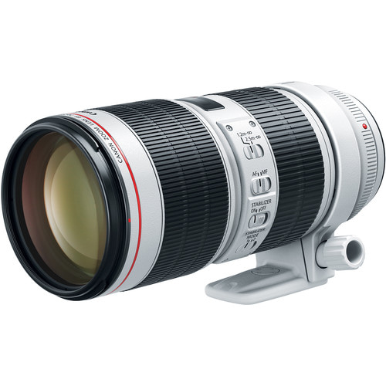 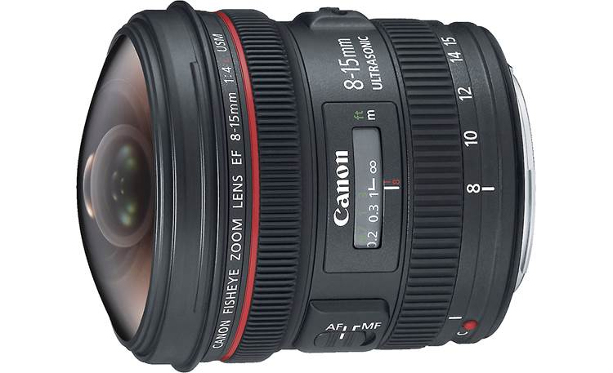

Canon 70-200 mm telephoto Canon 8-15 mm wide-angle lens

**Variable focal length lenses vs Prime Lenses -** Both lenses above have *variable* focal lengths. Lenses with fixed focal lengths are called *prime lenses*, such as the 50mm lens below on the right. The lens below on the left has a variable focal length, from 24-105mm. (A good all-around lens.)

|  |  |
| --- | --- |
| Canon RF 24-105mm f/4 L IS USM Lens  Canon EF 24-105 mm f/4 zoom lens | Canon EF 50mm f/1.2L USM Lens Canon EF 50mm f/1.2 prime lens |

**Introducing Interchangeable Lenses**

The Canon xf605 has a variable focal length lens (a *zoom* lens), which is permanently attached to the camera. Most cinema cameras use an interchangeable lens system- so a variety of different lenses can be used with a single camera body. You can use zoom lenses, prime lenses (which have fixed focal lengths) and specialty lenses like tilt-shift, fisheye/wide-angle, and macro.

**Image Sensors and Lens Mounts** (EF-S, EF, RF, PL, etc.) Lens mounts are precisely engineered to connect a lens’s electronics and optics to a specific type of camera body. (You’d attach an EF lens to a camera with an EF lens mount.) Lens mounts are designed to match the size of the camera’s image sensor. In the Media School we have Canon cameras with different sizes of image sensors (APS-C, Super 35, and 35mm). The Canon C100, C200, and C300 cameras use EF lenses, but the R5C uses RF lenses. [Wikipedia has a good comparison of sensors](https://en.wikipedia.org/wiki/APS-C#/media/File:Sensor_sizes_overlaid_inside.svg).

|  |  |  |  |
| --- | --- | --- | --- |
| Sensor Type | Size (approx.) | Cameras | Compatible lenses |
| APS-C | 22.5 x 15 mm | Canon Rebel, 80D | EF-S, EF |
| Super 35 | 24.6/26.2 x 13.8 mm | C100, C200, C300 | EF |
| 35mm / Full frame | 36 x 24 mm | Canon 1D, 5D, 6D | EF |
| 35mm / Full frame | 36 x 24 mm | Canon R5, R5C | RF |

It is possible to attach lenses with a particular mount to cameras with different mounts using an appropriate lens adaptor. For example, I use an EF to RF adaptor, which (so far) works flawlessly. There are many other types of lens mounts (Canon RF, Nikon F, Sony A & E, Arri PL, etc.), which you may encounter.

**WARNING** – Changing lenses should only be done in a clean, dust-free environment. Make sure your hands are clean, you have a good surface to place the camera on, and you have caps for both sides (front and rear) of the lens and the camera body itself. Do NOT change lenses without first getting proper guidance. [The Black and Blue Guide to Changing Camera Lenses.](https://www.theblackandblue.com/2011/03/31/how-to-exchange-camera-lenses/)

**REVIEW: The Relationship of Aperture and Depth of Field**. Larger apertures (E.g., f-2) have a shallower depth of field than smaller apertures (E.g., f-22).

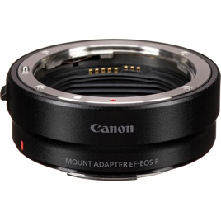**Canon EF-R Adaptor** – Approx $112.00

**Lens Speed** – Lenses can be categorized as *slow* or *fast*, which can be confusing. This pertains to the maximum size of the aperture. Slow lenses may only open to f-4 or f-5.6. A fast lens may open to f-2. Photographers must use a slower shutter speed with a slower lens but can use a faster shutter speed with a fast lens. With their larger apertures, fast lenses make it easier to get shots with a shallow depth of field. Fast lenses are also essential for photographers who must capture crisp shots of action (racing, sports, dancers, animals in motion, etc.). Fast lenses are more expensive than slower lenses. Check out the price difference of these two telephoto lenses:

* Tokina EF SZX 400mm f/9 [($270 at B&H](https://www.bhphotovideo.com/c/product/1580877-REG/tokina_szxmf400_c_szx_400mm_f_8_reflex.html))
* Canon EF 400mm f/2.8 [($12,000 at B&H](https://www.bhphotovideo.com/c/product/1433721-REG/canon_ef_400mm_f_2_8l_is.html))

**Intro to the Canon C100 Mark II and the R5C**

The Canon C100 Mark II, released in 2014 has a Super 35 CMOS sensor with approximately 3840x2160 pixels. It uses an EF mount so can work with either EF or EF-S lenses. It has 4 glass filters (clear, 2 stops, 4 stops, and 6 stops) operated by a dial on the camera body. It takes SD/SDHC/SDXC cards.S

The Canon R5C is a 45-megapixel mirrorless camera with a full-frame CMOS sensor and an RF lens mount. It requires an LP-E6N battery and can record HD, 4K, and 8K. ([B&H R5C info page](https://www.bhphotovideo.com/c/product/1684244-REG/canon_5077c002_eos_r5_c_full_frame.html/specs))

* Unlike the Canon xf605, which has a fixed lens, the R5C uses interchangeable RF lenses.
* Unlike the Canon xf605 (and like most DSLRs) there is no direct way to capture audio from a microphone via an XLR cable. While you can attach an external mic with the right connectors (mini-phone plug), it is best to record audio via a separate device (E.g., a Sound Device MixPre), which has phantom power to work with professional microphones).

Side by side comparison: ([Google AI](https://www.google.com/search?q=Canon+r5c+vs+c100&client=safari&sca_esv=fde65a004f3df79d&rls=en&ei=_768Z-TmFtetptQPyvikwA4&ved=0ahUKEwik4pDL_NyLAxXXlokEHUo8CegQ4dUDCBA&uact=5&oq=Canon+r5c+vs+c100&gs_lp=Egxnd3Mtd2l6LXNlcnAiEUNhbm9uIHI1YyB2cyBjMTAwMgUQIRigATIFECEYoAEyBRAhGKABMgUQIRigATIFECEYoAFI_j9Q0AhY-j1wAXgBkAEAmAGAAaAB2guqAQQxMi41uAEDyAEA-&sclient=gws-wiz-serp))

|  |  |  |
| --- | --- | --- |
|  | Canon C100 Mark II | Canon R5C |
| Sensor | Super 35 CMOS - 3840x2160 pixels | Full-Frame CMOS 8192x5464 |
| ND filters | Yes | No |
| Video formats | Maximum is HD (1920 x 1080) 35 Mbps | 8K @ 60 fps |
| Recording media | SD/SDHC/SDXC (x 2) | CF Express &  SD/SDHC/SDXC |
| Battery | BP-955 or BP-975 | 1 LP-E6NH |
| Audio | Pro audio inputs (XLR + Phantom power) | Stereo mini TRS microphone input |
| Lens Mount | EF | RF |
| Continuous recording time | Up to 405 minutes with BP-975 | 30 min (varies) |
| Approx Cost | Used $1,500 (no lens) | $3,400 (no lens) |

**Visual Narrative Project:** [**https://iu.instructure.com/courses/2288499/assignments/17288579**](https://iu.instructure.com/courses/2288499/assignments/17288579)

**Visual narrative example:** [**The Black Hole**](https://vimeo.com/233646913)

**Attendance Question**: What is the two-letter lens mount that works with the Canon R5 and R5C cameras?

**Vocabulary:**

* Angle of view
* Aperture
* Depth of field
* DSLR Camera (Digital Single Lens Reflex Camera)
* EF & EF-S lens mounts
* F-stop
* Focal length
* Jump Cut
* Insert shot
* Lens speed
* Prime lens - A lens with a fixed focal length.
* RF
* Zoom lens - A lens that has a variable focal length