C229 Lecture Week 9 - Spring 2024

Agenda:
- Continuity Review
- History of the Jump Cut
- Coverage - tips & examples
- Upcoming production exercises (Storytelling using a Visual Narrative)

Readings/Watchlist:
- Camera Coverage (Wikipedia)
- A Beginner’s Guide to Shooting Coverage for a Film Project
  - https://youtu.be/RMjDbJ6gIaY
  - https://www.youtube.com/watch?v=EBykqNDKbKY
- What is a Jump Cut (Studio Binder – Georges Méliès – Martin Scorsese’s movie Hugo was a tribute to him)
- How to Use B-roll footage in Filmmaking and Editing (Backstage Magazine)
- We got that B-roll!
- The History of Cutting – The Birth of Cinema and Continuity Editing (Filmmaker IQ – 14 min)
from last week:
- Canon 80D manual (Familiarize yourself with it, get to know where things are like setting shooting modes, setting white balance, etc.) You might want to download it to your phone.
- Continuity Editing in Film (Studio Binder)
  - The 180-degree Rule
  - The 30-degree Rule in Filmmaking (3:30)
  - Match Cuts
  - Eye Trace
- Cuts & Transitions 101 (Rocket Jump Film School)

Review: Continuity in TV and film: Within a scene, we expect people and props to remain faithful to their physical position, direction, and motion, and for time to move forward. We do not want to take viewers out of the moment by introducing distractions, unintentional jump cuts and continuity errors. Typical continuity errors:
- Spatial Continuity - the 180-degree axis has been crossed or eyelines don’t match, etc.
- Time Continuity - Clocks, lengths of candles or cigarettes, amount of wine in a glass, etc.
- Physical Continuity - props and clothing change from shot to shot.
- Technical Continuity - shots don’t match in texture, image quality or sound.
- Story Continuity – A story point or character action doesn’t make sense.
30° Rule – (The 30° Rule in Filmmaking 3:30) To avoid unintentional jump cuts, be sure to vary the camera by at least 30°. It’s also important to cut to shots that are noticeably different. For example, going from an MCU of a subject to a CU of the subject from another camera at least 30° different. Otherwise, you get a jump cut.

Jump cuts and continuity errors have a place in filmmaking and TV- but only when they are used intentionally with a clear purpose. Jump cut sequences are commonplace in movies. Some movies intentionally toy with continuity- movies like Memento, Westworld Season 1, the Limey, Eternal Sunshine of the Spotless Mind. (Review: What is a Jump Cut?)

Run Lola Run is a German 1998 art thriller film that does a marvelous job at melding continuity and non-continuity production techniques. Essentially, Lola finds out her boyfriend needs a lot of money in a short amount of time- and several variations of reality play out. Take a look at this scene from Run Lola Run and how the story experiments with continuity techniques.

How to Avoid Continuity Errors:

Spatial Continuity - Established and maintain a 180-degree line, match eye lines, and follow the 30-degree rule.
- 180-degree line – Keep the camera(s) on one side of the line- unless you have a way to cross it.
    - Ways to cross the 180-degree line: introduce a neutral shot, a cutaway, some B-roll, an insert shot, a new character or vector. One can also shoot down the line and move the camera across the line. Check out the primary line of action in this scene from the Matrix and how they shoot down the line and cross the line with a camera move. Later when Trinity is running across the rooftops from left to right- she subtly crosses the line, introducing a new motion vector.
  - A cutaway shot is a shot of something new, outside the action of a scene.
  - Insert shots are often captured from the point of view of the character and can be a close-up detail of something inside the scene they are looking at.
  - B-roll is a term often associated with news coverage and documentaries, but it’s also used in narrative filmmaking. It’s similar in concept to cutaways- B-roll is supplemental footage used to drive the narrative. If a character in a movie (or an interview subject) is describing something, B-roll can be used to illustrate the narrative- and is useful for covering jump cuts in an interview. (We got that B-roll) Where does the name come from? The main interview footage or storyline would be considered A-roll. Anything cut on top of it is considered B-roll.
- Match eye lines – This takes planning and thoughtful camera placement to make sure character’s eye lines match. Almost any dialog scene in TV or film does this seamlessly.
- 30-degree rule – (Wikipedia article) To avoid unintentional jump cuts (back-to-back similar shots of the same subject), change the shot by at least 30 degrees. It’s important to vary the framing for adjacent shots of the same subject. (E.g., Don’t go from a CU to CU of the same character unless you want a jump cut.)

Time and Physical Continuity - Pay attention to attire, hair, clocks, candles, time, and anything that changes over time. Even the amount of liquid in a glass someone is drinking needs to be monitored. On set, the Script Supervisor is usually tasked with tracking props and continuity issues.

Technical Continuity – Using two cameras that don’t match, varying lighting conditions in the same scene, and mismatched audio recordings are common problems.

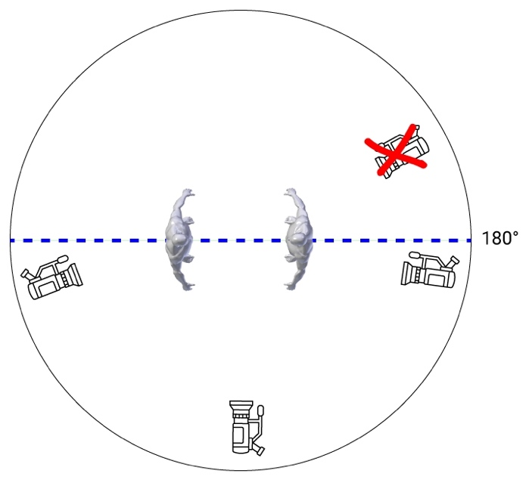 | 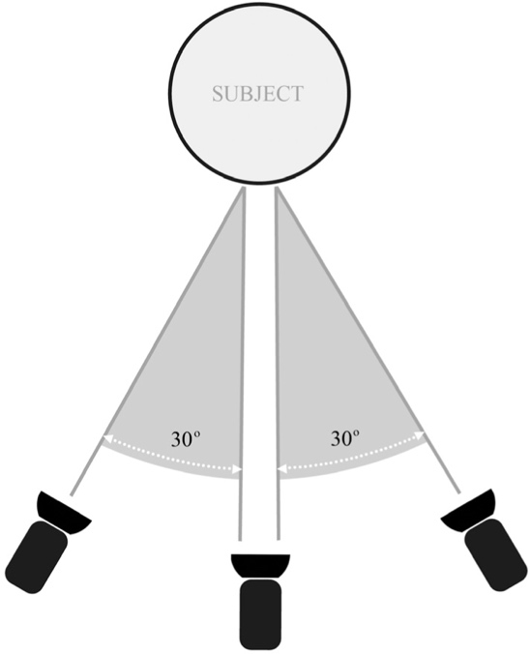
180-degree line of action | 30-degree rule

Coverage – Coverage is capturing all the shots needed for a film- or a scene in a film.
  - See Camera Coverage (Wikipedia)

In addition to getting coverage within a scene, it’s often necessary to capture transitionary shots to show the passage of time. Establishing shots can show us where we are and can be captured in a different location than where a scene is actually shot. (On the Seinfeld Show we often see an exterior tilt-up on Jerry’s apartment complex, which is a building in NY. The interior apartment scenes are shot in a studio.)

Tips for Lab this week’s Continuity Exercise:

Edits work best when they are motivated. Cutting on action is the best way to motivate an edit. The motion doesn’t have to be huge- the subtlest of actions are all that is needed to motivate the action (a glance, a nod, etc.)

- Come up with a simple scene or scenario that has action. (Entering the building and meeting a friend, sitting at a desk, getting something from the vending machine, etc.)
- Visualize the flow of shots and action, keeping the 180-degree rule and the 30-degree rule in mind.
- Put this into the form of a storyboard with 7 to 10 shots.
- When capturing footage/clips, use overlapping action to connect two adjacent shots. These shots should follow the 180 and 30-degree rules. Capturing overlapping action is a common technique used in capturing B-roll.

Consider these examples of simple continuity scenes form P351:
- Ethan Levy
- Carly Graham
- Sean Massura
- Greg Eismin

Upcoming Week 11 1st Narrative Project:
In groups of 5 or 6:
- Create a 3-minute short film, in which you tell the story of two people meeting somewhere (to have coffee, study, whatever). One of the characters is flustered or angry, and the other is calm and collected. When they finally meet, it's up to you whether they get along or don't. Use your knowledge of framing and lenses to tell the story with only the shots! You don’t need any dialogue or music- but can add them if you like.
- Filmed in appropriate fps and shutter speed, 1920 x 1080, with proper white balance, focus, and exposure.
- Exhibits knowledge of 180-degree rule, 30-degree rule, coverage/continuity, and visual storytelling
- Final product delivered as H.264
- Use the C100 Camera (or 80D if you prefer) and whichever lenses you want.
Visual Narrative – A story told mainly through imagery. Examples:

- Stuck - https://vimeo.com/187708515
- Cart - The Film - https://vimeo.com/5843895
- The Black Hole - https://vimeo.com/70751621

Visualization exercise: Someone has an engagement ring in a small box that he/she plans on giving to their sweetheart. He/she is waiting for him/her with nervous anticipation on a park bench. Imagine you have just 3 shots to setup (start) the scene, introducing the (potential) fiancé into the frame in the last shot.
How will you approach this? (FYI You do have access to handheld stabilizers, sliders, and even a mini-jib. Whether you want to use these is up to you, as setup takes time.)

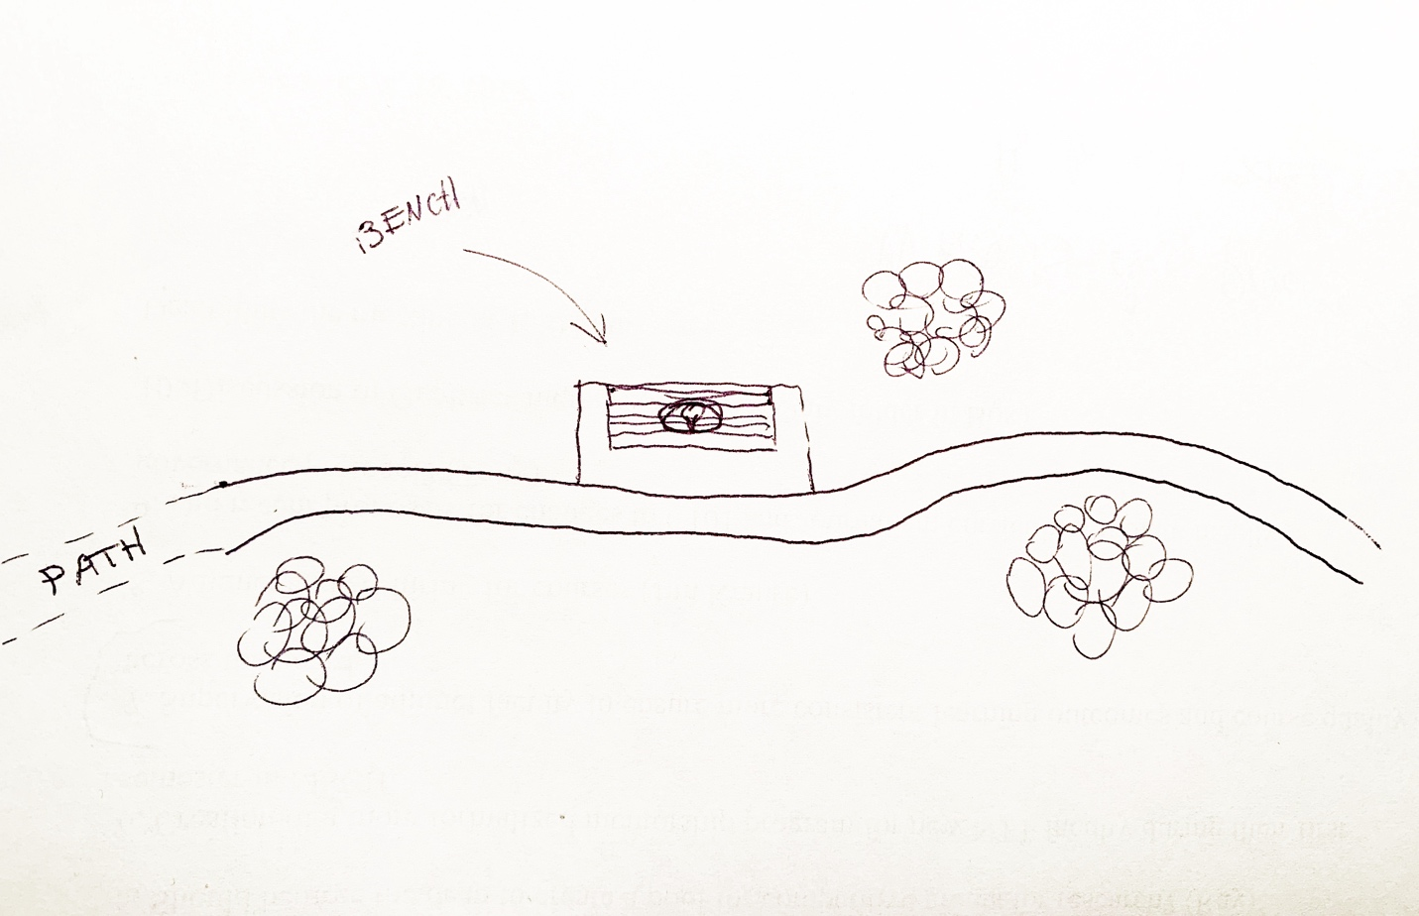

- Shot: _____________________
- Shot: _____________________
- Shot: _____________________

Attendance question (2 parts): A) What is the name of the continuity error attributed to an early French film pioneer and B) What is the filmmaker's name?

Vocabulary:
- 30° Rule
- 180° Line (know how to cross it & change it)
- B-roll
- Continuity
  - Spatial
  - Time
  - Physical
  - Technical
- Coverage
- Jump Cut (origin)
- Match action

